**Impact of climate change on present and future special distribution of *Mangifera indica L –* mango**

Name: Michał Pawlik

student number: s2631482

**Introduction:**

The species that I chose for this study is *Mangifera indica L.* commonly known as mango.

Mango is a tree whose fruit has been part of people diet for over 1000 years. They are tropical/sub-tropical fruit-bearing tree that has significant economic importance (Calatrava-Requena, 2014).

They are deep-rooted trees, with symmetrical evergreens that grow up to 25 meters tall. Mature branches bear around several hundred flowers that are around 0.6 cm in diameter. Most of the flowers only provide pollen for pollinators such as bees and wasps but the sometimes are bisexual. Mango fruit can weigh between 0.1 to 1,3kg (Bally, 2006). The skin of an immature fruit is green and tough and as it becomes ripe it turns yellow/orange and becomes softer. Each fruit has one seed inside, it has a flat shape and sticks to the flesh of the fruit.

Nowadays mango is cultivated across tropical and sub-tropical region between latitudes 33oS and 37oN and is 5th most consumed fruit in the world (Calatrava-Requena, 2014). Its importance can’t be overlooked on global scale but also for local, rural populations.

This research will focus on “How will climate change scenario rcp45 impact the potential loss and/or gain of *Mangifera indica L.* habitable range.” With the hypothesis that “Scenario rcp45 will allow the mango to extend its habitat range in the future (2050). Research is going to use Spatial distribution modeling done in maximum entropy (MAXENT), ArcGIS and R.

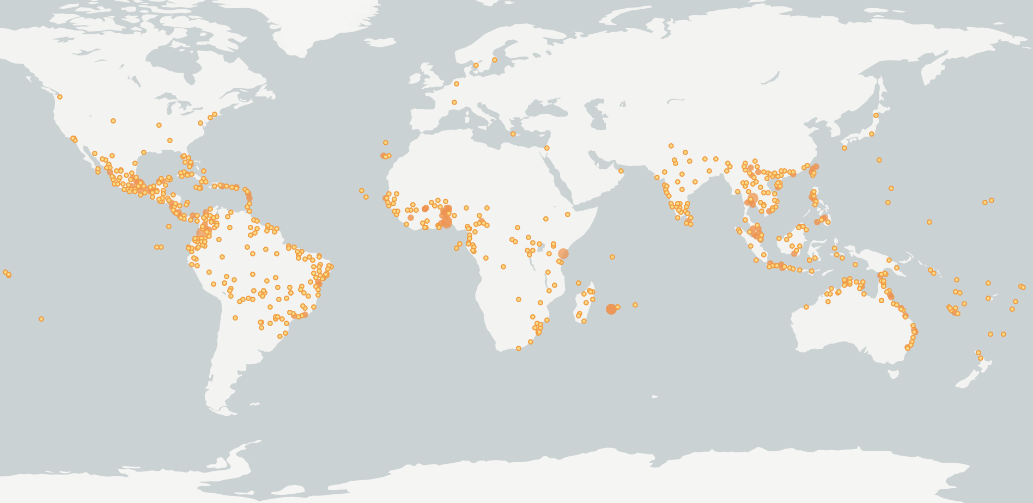

Figure 1Current distribution of the mango, derived from GBIF.org

**Methods:**

The distribution data for mango sequences was take from the GBIF with known coordinates. The occurrence data was cleaned in ArcGIS. There were couple of occurrences from USA, Netherlands, Northern Japan, the Ocean and Sweden that were removed due to the fact that they were not falling in the mango’s niche. Bioclim website was used to acquire the climate variables. For the present distribution (1960-1990) we used a grid of 5 min resolution. For the future (2050) the climatic variables I chose were derived from the rcp45 (representative concentration pathway 4.5) from the model HadGEM2-AO at 5 min resolution as well. In R we chose the bioclimatic indicator from the correlation table that had a value lower than -0.7 or greater than 0.7. For the bioclimatic variables I settled on:

Bio2 – Mean Diurnal Range (Mean of monthly (max temp – min temp))

Bio4 – Temperature Seasonality

Bio13 – Precipitation of Wettest Month

Bio15 – Precipitation Seasonality

Bio19 – Precipitation of Coldest Quarter

Mango to grow requires temperature between 15 and 30oC, in lower temperatures the grows slows down. The presence of distinct dry and wet season stimulates the flowering, but rainfall present during flowering season reduces the amount of fruit (Bally, 2006).

With the chosen parameters and occurrence data the model was generated with MAXENT software. The settings proposed in manual were used in creation of the model. Auto features, Create response curved, Make pictures of predictions and Jackknife options were turned on. Output format was set to Logistic with the file type set to asc.

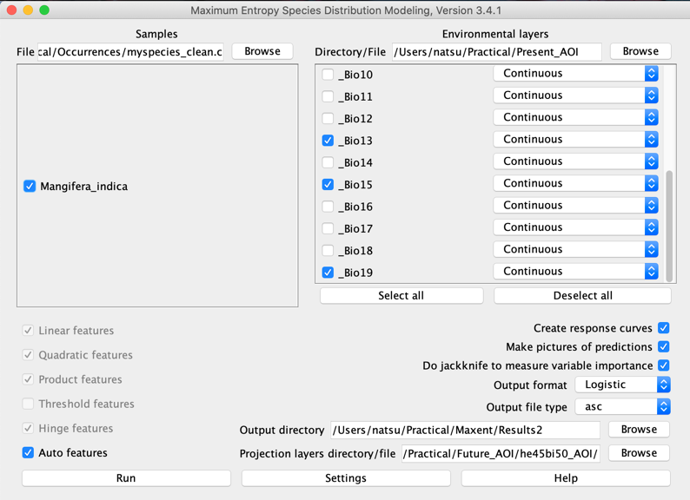

Figure 2 Settings chosen in MAXENT used in model creation

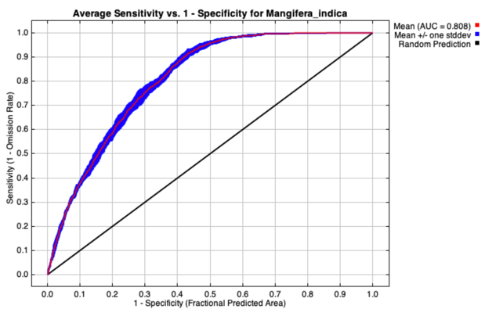**Results:**

Figure 3 Receiver operating characteristic (ROC) curve with the AUC of the training data

The mean value of AUC is 0.808 (Fig.3) which is above 0.8 threshold, meaning that the model is accepted as a distribution model. According to the contribution tables (Table1); precipitation of wettest month (bio13) has the biggest influence on the model. When looking at maps mango has far wider potential distribution range than it actual one based on occurrences.

Table 1 Calculation of the environmental variable contribution to the model

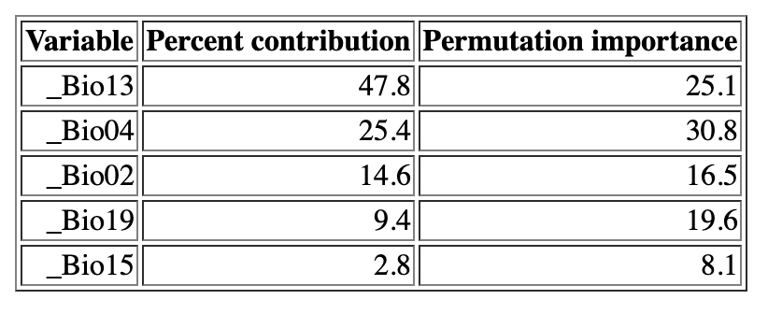

When we take a look at the maps showcasing potential present and future climate estimations for 2050 there seem to be small if any change visible. Due to low resolution of maps made in R it is hard to see the difference but there are slight differences in Africa, south America, Europe and Asia (Fig.4&5). This points out that the climate change in the future based on the chosen RCP 4.5 scenario does not have a strong impact on suitable habitat for the mangos.

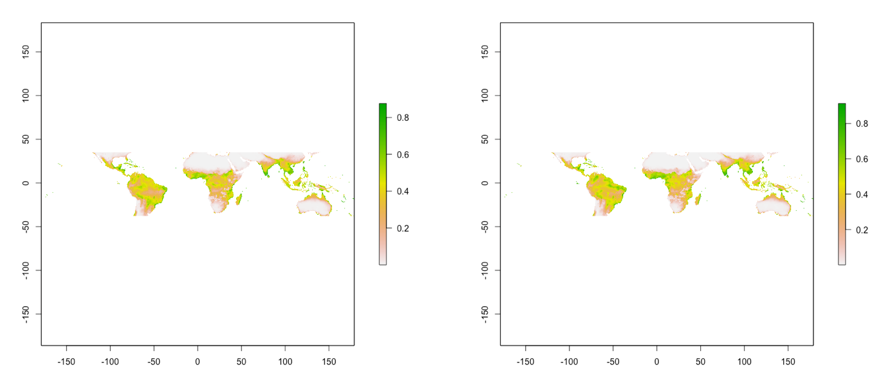

Figure 4 The potential present global distribution of the mango. Figure 5 The potential future distribution of the mango

Next, we used an average of selected threshold, in this case “Equal test sensitivity and specificity” where average is 0.42, to calculate the difference between present and future change in habitat suitability (Fig 6&7). Green areas indicate gain of the suitable habitat and red indicates loss, with fig.6 we can see the aforementioned gain of area in Africa, south America, Europe and Asia.

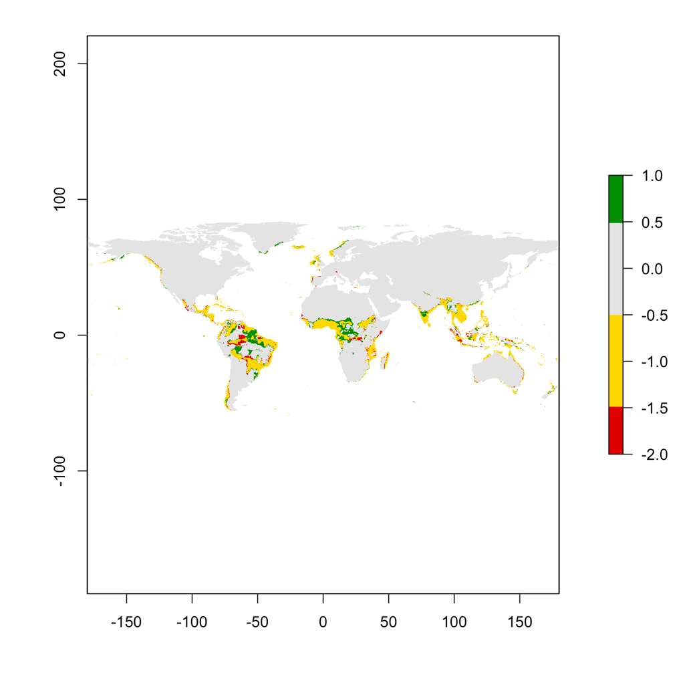

Figure 6 Differences in suitable habitat of mango between present and future at global scale according to the model

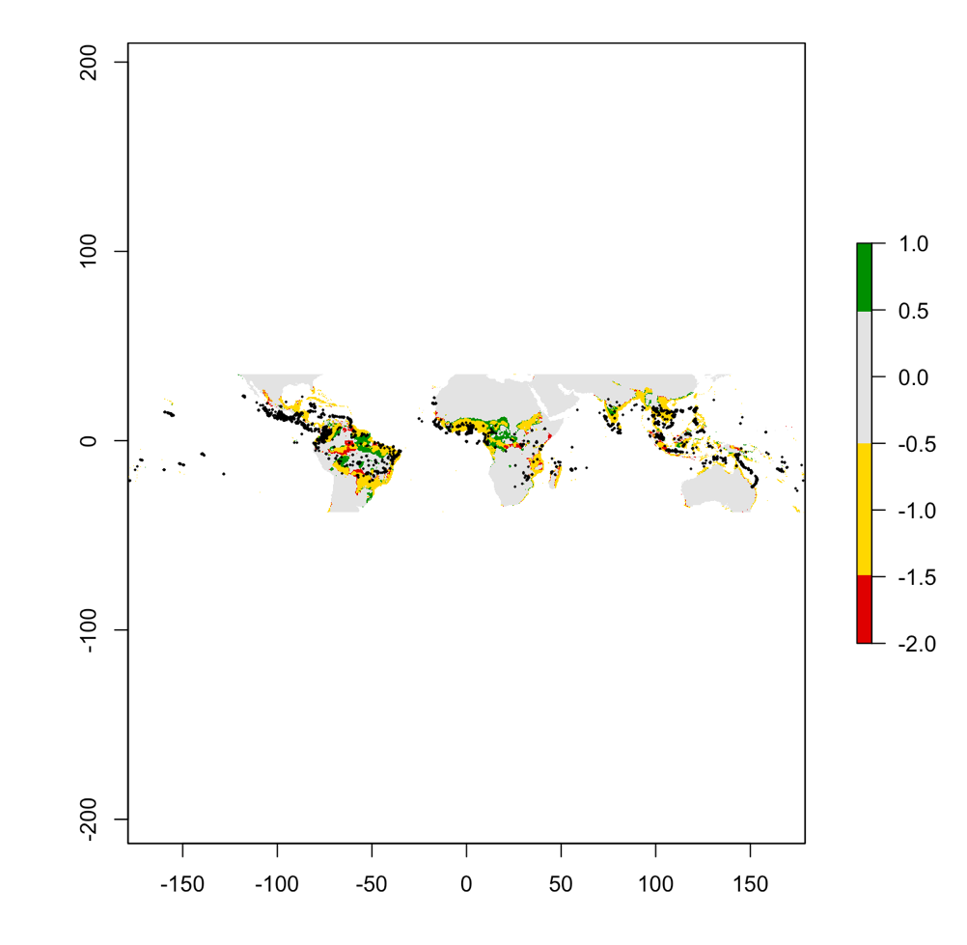

Figure 7 Differences in suitable habitat of mango between present and future at occurrence scale according to the model

**Discussion:**

The distribution of mangos suitable range is not going to change much due to climate change. As shown by the models we can see some expansions in south and north direction from the equator. There are some losses but there is more area gained overall. What is interesting is the emergence of suitable areas in Iceland, Greenland and northern Norway according to the model. That is probably caused by chosen variables of temperature seasonality and precipitation of the wettest month that are main contributors in this model. The mango preference towards tropical/sub-tropical climate would make it impossible to grow in these parts of the world.

The model was run 5 times which should give small stochastic effect on pseudo-absences. What all SDM lack is the ability to accommodate land use which is an ongoing topic of research with stronger correlation do biodiversity loss that climate change. Also, things like biotic and abiotic factors, rapid spread of invasive species and emergence of new subspecies of mango could pay a role on the distribution model.

**References:**

Calatrava-Requena, J. Retrieved 9 December 2019. Mango: *Economics and International Trade*.

Choudhary, J., Mali, S., Fand, B., & Das, B. Retrived 9 December, 2019. *Predicting the invasion potential of indigenous restricted mango fruit borer, Citripestis eutraphera ( Lepidoptera : Pyralidae ) in India based on MaxEnt modelling*.

Kostermans, AJHG; Bompard, JM (1993). *The Mangoes: Their Botany, Nomenclature, Horticulture and Utilization*

Bally, I.S. (2006) Mangifera indica. *Traditional Trees of Pacific Islands. Their Culture, Environment, and Use*

 Gepts, P. (n.d.). "PLB143: *Retrieved 9 December, 2019*. Crop of the Day: Mango, Mangifera indica". The evolution of crop plants. Dept. of Plant Sciences, Sect. of Crop & Ecosystem Sciences, University of California, Davis.

Lauri, P., Normand, F., & Legave, J Retrieved 9 December 2019. *CLIMATE CHANGE AND ITS PROBABLE EFFECTS ON MANGO PRODUCTION AND CULTIVATION.*

Sivakumar, D., Jiang, Y., & Yahia, E. Retrieved 9 December 2019). *Maintaining mango (Mangifera indica L.) fruit quality during the export chain*

*Note: All of this was done on MacBook hence why I couldn’t really get ArcGIS to work on my pc. That is why the maps are not that nice and the occurrence data was pulled from GBIF directly and has some of the unwanted points present.*